identify name and roles
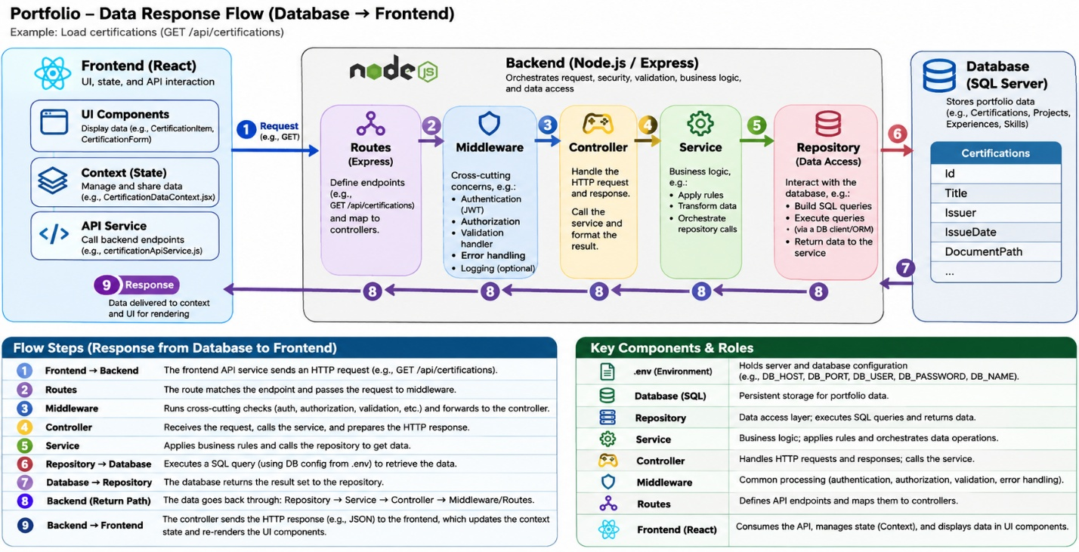
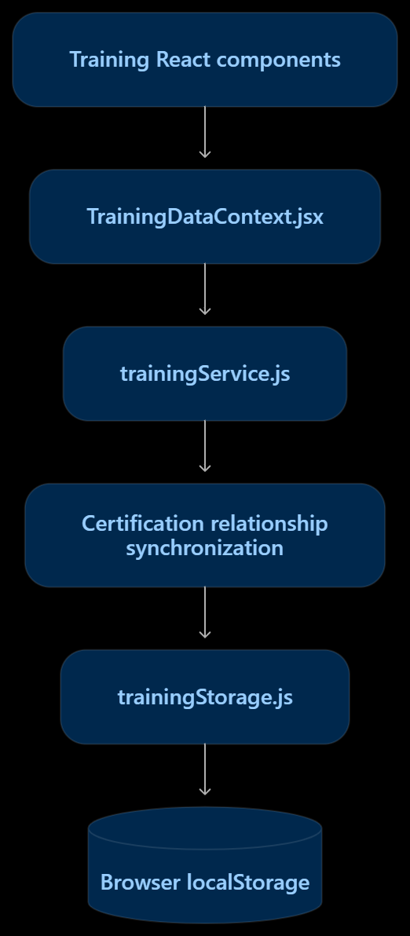
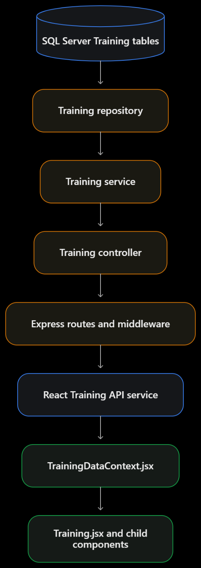
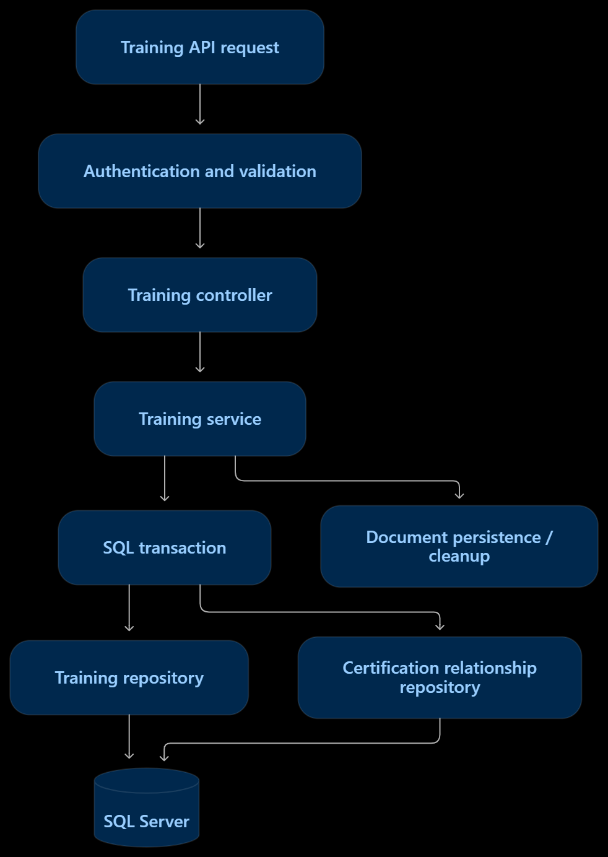
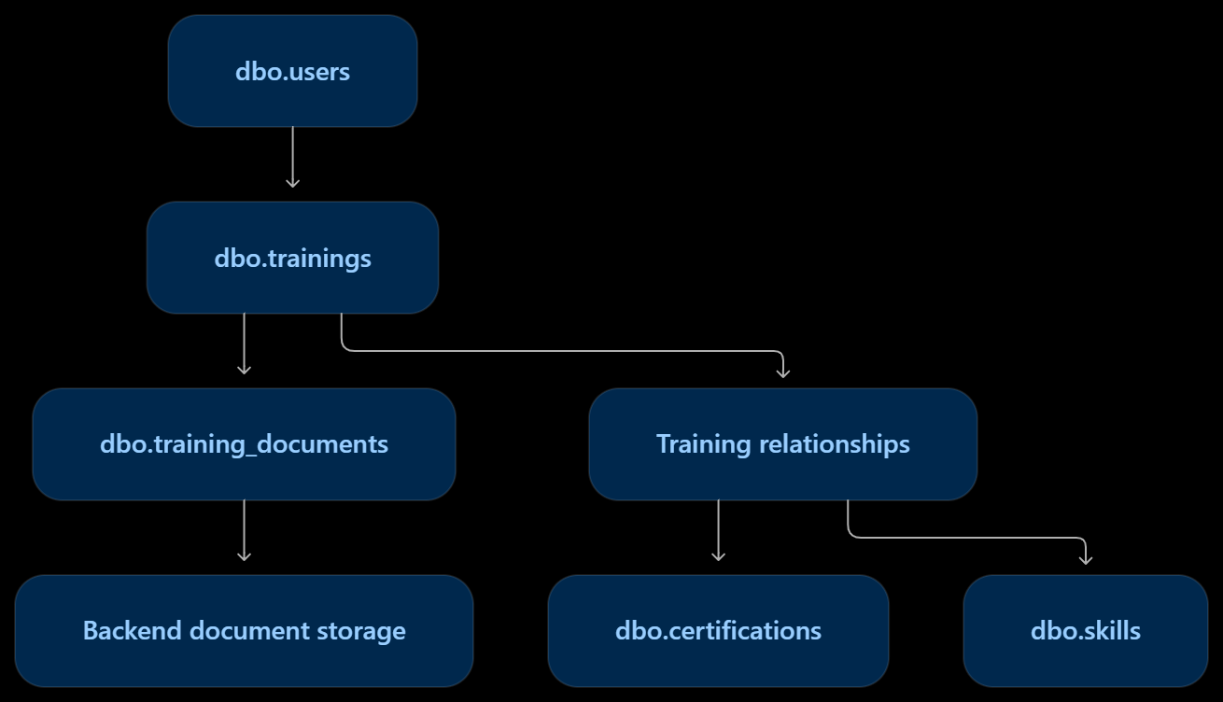
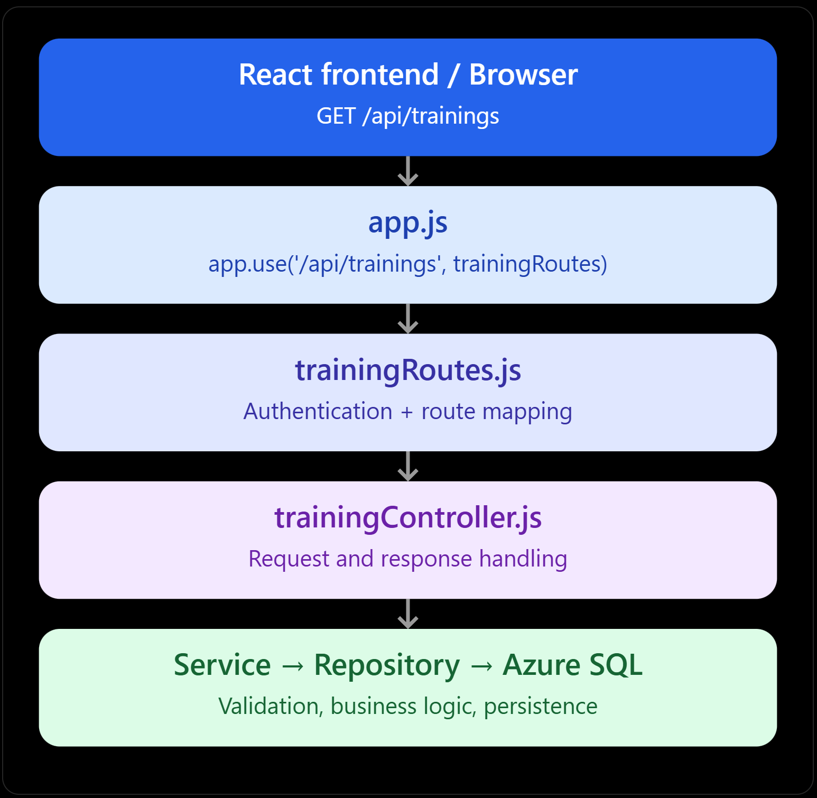
For your Portfolio Platform, the easiest way to understand the architecture is to follow one real example: opening your WEB101 certification, retrieving its information from SQL Server, and displaying it in React.
Your stack is:
Microsoft SQL Server → Node.js / Express backend → React frontend
The important distinction is that a request travels from the frontend toward the database, while the response travels back in the opposite direction.
1. Complete Portfolio architecture
Request direction
Frontend → Database
React frontend
Page → Context → API service → HTTP client
HTTP GET /api/certifications/:id
Node.js / Express backend
Middleware
Auth, CORS, security
Routes
Match API URL
Controller
Handle HTTP request
Schema
Validate data
Service
Business logic
Repository
SQL operations
Database connection pool + environment configuration
Parameterized SQL query
Microsoft SQL Server
Tables, records, rowVersion, transactions
Response direction
Database → Frontend
SQL result → Repository → Service → Controller → JSON response → API client → Context → React component
This is the conceptual architecture. Middleware, validation, and error-handling order can vary slightly depending on how your Express application is configured.
2. Backend: which file does what?
Using your Certification module as an example:
Layer | Example file | Responsibility
Configuration | .env | Stores database host, name, credentials and application settings
DB connection | Database connection/pool module | Reads configuration and establishes SQL connections
Repository | certificationRepository.js | Executes SQL queries, maps rows, returns records
Service | certificationService.js | Applies business rules, manages update workflows and calls repositories
Controller | certificationController.js | Receives HTTP requests, calls services, sends JSON responses
Schema | certificationSchemas.js | Defines and validates acceptable data structures
Routes | certificationRoutes.js | Maps URLs and HTTP methods to middleware and controllers
Middleware | Authentication, authorization, error handlers | Protects endpoints and handles common request/response concerns
App/server | app.js, server.js or equivalent | Configures Express, middleware, routes, and starts the server
One correction to your original understanding: the repository normally does not read .env directly for every query. A dedicated database configuration/connection module loads the settings and provides a connection pool that repositories use.
Also, schemas are not necessarily a separate execution step between services and controllers. They are definitions used wherever validation is required, commonly before business logic runs.
3. Actual request order
For your WEB101 certification, the request is approximately:
React Certification PageCertificationDataContext.jsxcertificationApiService.jsapiClient.jsHTTP GET/api/certifications/:idExpress app.jsGlobal middleware: CORS,security, JSON, auth asconfiguredcertificationRoutes.jsRoute middleware:authentication, authorization,validationcertificationController.jscertificationService.jscertificationRepository.jsSQL connection pool.env / configurationSQL Server
4. Response order: database back to React
Once SQL Server has found your certification, the response travels back:
SQL ServerSQL query resultcertificationRepository.jscertificationService.jscertificationController.jsExpress HTTP responseapiClient.jscertificationApiService.jsCertificationDataContext.jsxCertifications.jsxCertificationItem.jsxWEB101 certification displayed
The frontend response typically looks like:
{
"status": "success",
"data": {
"certification": {
"id": "certification-...",
"name": "WEB101-Certification",
"description": "Intro to Web Development",
"rowVersion": "AAAAAAABpeE="
}
}
}
Your API service extracts the certification object, the context stores it in React state, and React renders the updated interface.
5. What happens when you click Edit → Save?
This is similar to Read, but uses a different HTTP method and adds validation, concurrency checks, and database writes.
1. React form
CertificationForm.jsx collects the edited fields.
2. React context + API service
CertificationDataContext.jsx invokes patchCertification(), which uses apiPatch() in apiClient.js.
3. Express route + middleware
Verifies authentication and applicable permissions, then passes the request to the controller.
4. Controller + service + schema
Validates the request, checks allowed metadata changes, and prepares the update.
5. Repository + SQL Server
Executes a parameterized update and checks rowVersion for concurrency.
6. Response
Returns HTTP 200 with the updated certification and new rowVersion; React updates its state.
6. Important architectural concepts
Security is not just one file. Your system can enforce security at several layers: HTTPS, CORS, authentication middleware, authorization, input validation, parameterized SQL queries, and database permissions.
The frontend should never connect directly to SQL Server. The backend controls access and prevents exposing database credentials in browser code.
The database does not normally initiate the response. The frontend makes a request, and the backend retrieves the data. Real-time updates require a separate mechanism, such as WebSockets or server-sent events.
.env is configuration, not a service. It provides settings to backend modules; it does not execute SQL queries or handle HTTP requests.
The main sequence to memorize is:
Frontend request: Component → Context → API service → HTTP client → Route/Middleware → Controller → Service → Repository → SQL Server.
Database response: SQL Server → Repository → Service → Controller → HTTP response → API client → API service → Context → Component.
That is the core architecture behind your Portfolio Platform.
ok now let's start working on Training migration for portfolio, we are going to scan, than we are goind to list the steps from database to frontend that we are going to implement, so we really understand what's going on
Perfect. We'll approach the Training migration for your Portfolio Platform the same way we handled Certifications: inspect first, understand the existing architecture, design the migration, then implement and verify each layer.
We will not modify any files or database tables during the initial scan.
Our migration roadmap
1
Discovery and inspection
Identify existing Training files, API endpoints, SQL tables, relationships and data storage
2
Database design
Confirm Training tables, columns, keys, constraints and migration requirements
3
Database connection and repository
Use the existing SQL connection pool; implement Training data access
4
Backend schemas and models
Define validation, normalization and API data contracts
5
Backend services
Implement business logic, transactions and relationships
6
Controllers, routes and security
Connect HTTP endpoints to services with appropriate middleware
7
Frontend API integration
Connect the Training API service and HTTP client
8
React context and components
Migrate Training state, forms, lists and detail views to backend persistence
9
Testing and migration verification
Validate CRUD, document handling, relationships, data preservation and failure cases
10
Git commit and push
Review staged files, verify no secrets, then commit the completed milestone
This is a provisional roadmap. We'll adjust it after inspecting the actual Training implementation.
Step 1 — Read-only Training architecture scan
Open PowerShell at:
Set-Location "D:\Documents\Project\Portfolio\portfolio-plateform"
Run the following script. It will inspect both frontend and backend, identify Training-related files and references, and save one report under your existing Persistence/reports directory.
It will not modify application source files, SQL Server, or Git.

$ErrorActionPreference = "Stop"

$root = "D:\Documents\Project\Portfolio\portfolio-plateform"
$reportDir = Join-Path $root "Persistence\reports"
$report = Join-Path $reportDir "training-migration-initial-scan.txt"

Set-Location $root

if (-not (Test-Path $reportDir)) {
throw "Report directory does not exist: $reportDir"
}

$frontend = Join-Path $root "frontend"
$backend = Join-Path $root "backend"

if (-not (Test-Path $frontend)) {
throw "Frontend directory not found."
}

if (-not (Test-Path $backend)) {
throw "Backend directory not found."
}

$lines = [System.Collections.Generic.List[string]]::new()

function Add-Section {
param([string]$Title)

$lines.Add("")
$lines.Add("=" * 75)
$lines.Add($Title)
$lines.Add("=" * 75)
}

function Add-Output {
param([object[]]$Items)

foreach ($item in $Items) {
$lines.Add([string]$item)
}
}

Add-Section "TRAINING MIGRATION - INITIAL READ-ONLY SCAN"
$lines.Add("Generated: $(Get-Date -Format 'yyyy-MM-dd HH:mm:ss')")
$lines.Add("Project: $root")

Add-Section "1. GIT STATUS"

Add-Output @(git status --short)
Add-Output @(git -C backend status --short)

Add-Section "2. TRAINING-RELATED FILES"

$files = @(
Get-ChildItem $frontend, $backend -Recurse -File |
Where-Object {
$_.FullName -notmatch '[\\/](node_modules|\.git|dist|build|coverage|uploads|backups)[\\/]' -and
$_.Name -match 'training'
} |
Sort-Object FullName
)

foreach ($file in $files) {
$lines.Add($file.FullName)
}

Add-Section "3. TRAINING REFERENCES IN SOURCE"

$extensions = @(".js", ".jsx", ".ts", ".tsx", ".sql")

$sourceFiles = @(
Get-ChildItem $frontend, $backend -Recurse -File |
Where-Object {
$_.Extension -in $extensions -and
$_.FullName -notmatch '[\\/](node_modules|\.git|dist|build|coverage|uploads|backups)[\\/]'
}
)

foreach ($file in $sourceFiles) {
$matches = @(
Select-String -LiteralPath $file.FullName `
-Pattern '\btrainings?\b' -ErrorAction SilentlyContinue
)

foreach ($match in $matches) {
$relative = [System.IO.Path]::GetRelativePath(
$root, $file.FullName
)

# Report line numbers, not source contents.
# This avoids copying possible secrets into the report.
$lines.Add("${relative}:$($match.LineNumber)")
}
}

Add-Section "4. BACKEND DATABASE / API FILE INVENTORY"

$backendFiles = @(
Get-ChildItem $backend -Recurse -File |
Where-Object {
$_.FullName -notmatch '[\\/](node_modules|\.git|dist|build|coverage|uploads|backups)[\\/]' -and
$_.Name -match 'repository|service|controller|route|schema|model|database|migration|config|server|app'
} |
Sort-Object FullName
)

foreach ($file in $backendFiles) {
$lines.Add(
[System.IO.Path]::GetRelativePath($root, $file.FullName)
)
}

Add-Section "5. FRONTEND API / CONTEXT FILE INVENTORY"

$frontendFiles = @(
Get-ChildItem $frontend -Recurse -File |
Where-Object {
$_.FullName -notmatch '[\\/](node_modules|\.git|dist|build|coverage|uploads|backups)[\\/]' -and
$_.Name -match 'apiClient|training|context|service'
} |
Sort-Object FullName
)

foreach ($file in $frontendFiles) {
$lines.Add(
[System.IO.Path]::GetRelativePath($root, $file.FullName)
)
}

Add-Section "6. ENVIRONMENT FILE NAMES (NO CONTENTS)"

Get-ChildItem $backend -Force -File |
Where-Object { $_.Name -match '^\.env' } |
ForEach-Object { $lines.Add($_.Name) }

Add-Section "END OF SCAN"

$lines | Set-Content -LiteralPath $report -Encoding UTF8

Write-Host ""
Write-Host "Scan completed." -ForegroundColor Green
Write-Host "Report: $report" -ForegroundColor Cyan
Write-Host "Training-related files: $($files.Count)"
Write-Host "Source files inspected: $($sourceFiles.Count)"
Write-Host "No application files or database records changed."
What we'll learn from this scan
We need to determine whether Training currently uses browser-local storage, whether SQL Server already contains a Training schema, and how Training relates to Skills, Certifications, and documents.
Once you share training-migration-initial-scan.txt, we'll examine the relevant files more deeply and produce a Training-specific database-to-frontend architecture diagram with the real filenames and responsibilities, rather than guessing.
Our first milestone is complete only when we understand the existing implementation and have a verified migration plan. We won't write migration code before that.
PS D:\Documents\Project\Portfolio\portfolio-plateform>
>> $ErrorActionPreference = "Stop"
>>
>> $root = "D:\Documents\Project\Portfolio\portfolio-plateform"
>> $reportDir = Join-Path $root "Persistence\reports"
>> $report = Join-Path $reportDir "training-migration-initial-scan.txt"
>>
>> Set-Location $root
>>
>> if (-not (Test-Path $reportDir)) {
>> throw "Report directory does not exist: $reportDir"
>> }
>>
>> $frontend = Join-Path $root "frontend"
>> $backend = Join-Path $root "backend"
>>
>> if (-not (Test-Path $frontend)) {
>> throw "Frontend directory not found."
>> }
>>
>> if (-not (Test-Path $backend)) {
>> throw "Backend directory not found."
>> }
>>
>> $lines = [System.Collections.Generic.List[string]]::new()
>>
>> function Add-Section {
>> param([string]$Title)
>>
>> $lines.Add("")
>> $lines.Add("=" * 75)
>> $lines.Add($Title)
>> $lines.Add("=" * 75)
>> }
>>
>> function Add-Output {
>> param([object[]]$Items)
>>
>> foreach ($item in $Items) {
>> $lines.Add([string]$item)
>> }
>> }
>>
>> Add-Section "TRAINING MIGRATION - INITIAL READ-ONLY SCAN"
>> $lines.Add("Generated: $(Get-Date -Format 'yyyy-MM-dd HH:mm:ss')")
>> $lines.Add("Project: $root")
>>
>> Add-Section "1. GIT STATUS"
>>
>> Add-Output @(git status --short)
>> Add-Output @(git -C backend status --short)
>>
>> Add-Section "2. TRAINING-RELATED FILES"
>>
>> $files = @(
>> Get-ChildItem $frontend, $backend -Recurse -File |
>> Where-Object {
>> $_.FullName -notmatch '[\\/](node_modules|\.git|dist|build|coverage|uploads|backups)[\\/]' -and
>> $_.Name -match 'training'
>> } |
>> Sort-Object FullName
>> )
>>
>> foreach ($file in $files) {
>> $lines.Add($file.FullName)
>> }
>>
>> Add-Section "3. TRAINING REFERENCES IN SOURCE"
>>
>> $extensions = @(".js", ".jsx", ".ts", ".tsx", ".sql")
>>
>> $sourceFiles = @(
>> Get-ChildItem $frontend, $backend -Recurse -File |
>> Where-Object {
>> $_.Extension -in $extensions -and
>> $_.FullName -notmatch '[\\/](node_modules|\.git|dist|build|coverage|uploads|backups)[\\/]'
>> }
>> )
>>
>> foreach ($file in $sourceFiles) {
>> $matches = @(
>> Select-String -LiteralPath $file.FullName `
>> -Pattern '\btrainings?\b' -ErrorAction SilentlyContinue
>> )
>>
>> foreach ($match in $matches) {
>> $relative = [System.IO.Path]::GetRelativePath(
>> $root, $file.FullName
>> )
>>
>> # Report line numbers, not source contents.
>> # This avoids copying possible secrets into the report.
>> $lines.Add("${relative}:$($match.LineNumber)")
>> }
>> }
>>
>> Add-Section "4. BACKEND DATABASE / API FILE INVENTORY"
>>
>> $backendFiles = @(
>> Get-ChildItem $backend -Recurse -File |
>> Where-Object {
>> $_.FullName -notmatch '[\\/](node_modules|\.git|dist|build|coverage|uploads|backups)[\\/]' -and
>> $_.Name -match 'repository|service|controller|route|schema|model|database|migration|config|server|app'
>> } |
>> Sort-Object FullName
>> )
>>
>> foreach ($file in $backendFiles) {
>> $lines.Add(
>> [System.IO.Path]::GetRelativePath($root, $file.FullName)
>> )
>> }
>>
>> Add-Section "5. FRONTEND API / CONTEXT FILE INVENTORY"
>>
>> $frontendFiles = @(
>> Get-ChildItem $frontend -Recurse -File |
>> Where-Object {
>> $_.FullName -notmatch '[\\/](node_modules|\.git|dist|build|coverage|uploads|backups)[\\/]' -and
>> $_.Name -match 'apiClient|training|context|service'
>> } |
>> Sort-Object FullName
>> )
>>
>> foreach ($file in $frontendFiles) {
>> $lines.Add(
>> [System.IO.Path]::GetRelativePath($root, $file.FullName)
>> )
>> }
>>
>> Add-Section "6. ENVIRONMENT FILE NAMES (NO CONTENTS)"
>>
>> Get-ChildItem $backend -Force -File |
>> Where-Object { $_.Name -match '^\.env' } |
>> ForEach-Object { $lines.Add($_.Name) }
>>
>> Add-Section "END OF SCAN"
>>
>> $lines | Set-Content -LiteralPath $report -Encoding UTF8
>>
>> Write-Host ""
>> Write-Host "Scan completed." -ForegroundColor Green
>> Write-Host "Report: $report" -ForegroundColor Cyan
>> Write-Host "Training-related files: $($files.Count)"
>> Write-Host "Source files inspected: $($sourceFiles.Count)"
>> Write-Host "No application files or database records changed."
>>
Method invocation failed because [System.IO.Path] does not contain a method named 'GetRelativePath'.
At line:87 char:9
+ $relative = [System.IO.Path]::GetRelativePath(
+ ~~~~~~~~~~~~~~~~~~~~~~~~~~~~~~~~~~~~~~~~~~~~~~
+ CategoryInfo : InvalidOperation: (:) [], ParentContainsErrorRecordException
+ FullyQualifiedErrorId : MethodNotFound
PS D:\Documents\Project\Portfolio\portfolio-plateform>
…
The error is caused by your PowerShell/.NET version, not by your Portfolio project.
Your script uses:
[System.IO.Path]::GetRelativePath($root, $file.FullName)
That method is available in newer .NET versions, but not in the .NET Framework used by Windows PowerShell 5.1.
Good news: The scan stopped before writing the report. No application files, database records, or Git history were changed.
Step 1 — Fix the compatibility issue
Instead of rewriting the entire script, we can use a compatible method to calculate relative paths.
Run this PowerShell command first:
$PSVersionTable.PSVersion
Then define this helper function:
function Get-ProjectRelativePath {
param(
[string]$Root,
[string]$FullPath
)

$normalizedRoot = $Root.TrimEnd('\', '/') + '\'

if ($FullPath.StartsWith(
$normalizedRoot,
[System.StringComparison]::OrdinalIgnoreCase
)) {
return $FullPath.Substring($normalizedRoot.Length)
}

return $FullPath
}
Step 2 — Replace the three occurrences
In the previous script, replace:
[System.IO.Path]::GetRelativePath($root, $file.FullName)
with:
Get-ProjectRelativePath -Root $root -FullPath $file.FullName
There are three occurrences: the Training source references, backend inventory, and frontend inventory.
Step 3 — Resume the scan
Because your previous script stopped during Section 3, we can reuse the variables and collected results already in your current PowerShell session.
Run:
$lines = [System.Collections.Generic.List[string]]::new()

Add-Section "TRAINING MIGRATION - INITIAL READ-ONLY SCAN"
$lines.Add("Generated: $(Get-Date -Format 'yyyy-MM-dd HH:mm:ss')")
$lines.Add("Project: $root")

Add-Section "1. GIT STATUS"
Add-Output @(git status --short)
Add-Output @(git -C backend status --short)

Add-Section "2. TRAINING-RELATED FILES"

foreach ($file in $files) {
$lines.Add($file.FullName)
}

Add-Section "3. TRAINING REFERENCES IN SOURCE"

foreach ($file in $sourceFiles) {

$matches = @(
Select-String -LiteralPath $file.FullName `
-Pattern '\btrainings?\b' `
-ErrorAction SilentlyContinue
)

foreach ($match in $matches) {

$relative = Get-ProjectRelativePath `
-Root $root `
-FullPath $file.FullName

$lines.Add("${relative}:$($match.LineNumber)")
}
}

Add-Section "4. BACKEND DATABASE / API FILE INVENTORY"

$backendFiles = @(
Get-ChildItem $backend -Recurse -File |
Where-Object {
$_.FullName -notmatch '[\\/](node_modules|\.git|dist|build|coverage|uploads|backups)[\\/]' -and
$_.Name -match 'repository|service|controller|route|schema|model|database|migration|config|server|app'
} |
Sort-Object FullName
)

foreach ($file in $backendFiles) {
$lines.Add(
(Get-ProjectRelativePath -Root $root -FullPath $file.FullName)
)
}

Add-Section "5. FRONTEND API / CONTEXT FILE INVENTORY"

$frontendFiles = @(
Get-ChildItem $frontend -Recurse -File |
Where-Object {
$_.FullName -notmatch '[\\/](node_modules|\.git|dist|build|coverage|uploads|backups)[\\/]' -and
$_.Name -match 'apiClient|training|context|service'
} |
Sort-Object FullName
)

foreach ($file in $frontendFiles) {
$lines.Add(
(Get-ProjectRelativePath -Root $root -FullPath $file.FullName)
)
}

Add-Section "6. ENVIRONMENT FILE NAMES (NO CONTENTS)"

Get-ChildItem $backend -Force -File |
Where-Object { $_.Name -match '^\.env' } |
ForEach-Object { $lines.Add($_.Name) }

Add-Section "END OF SCAN"

$lines | Set-Content -LiteralPath $report -Encoding UTF8

Write-Host ""
Write-Host "Training scan completed successfully." -ForegroundColor Green
Write-Host "Report: $report" -ForegroundColor Cyan
Write-Host "Training-related files: $($files.Count)"
Write-Host "Source files inspected: $($sourceFiles.Count)"
Step 4 — Verify the report
Test-Path "Persistence\reports\training-migration-initial-scan.txt"

Get-Item "Persistence\reports\training-migration-initial-scan.txt" |
Select-Object Name, Length, LastWriteTime
Once the report exists, upload training-migration-initial-scan.txt here.
We'll use it to identify the actual Training files and dependencies before deciding what needs to be implemented in SQL Server, the backend, and React.
We are still in Milestone 1: Discovery and inspection. No migration implementation has started yet
1. Current backend status
Component | Finding | Status
Training SQL tables | Migrations 013 and 014 | Complete
Training repository | Implemented | Complete
Training service | Implemented | Complete
Training controller | Implemented | Complete
Training routes | Implemented | Complete
Training schemas | Implemented | Complete
Training tests | In progress | To implement
Certification implementation | Existing reference components found | Available
Proposed Training repository testing strategy
Test level | What we verify | Database
1. Syntax validation | trainingRepository.js has valid JavaScript syntax | None
2. Unit tests | SQL parameter binding, row mapping, and row-version handling | Mocked
3. Integration tests | Actual INSERT, SELECT, UPDATE operations | Azure SQL
4. Ownership tests | One user cannot access another user's Training | Azure SQL
5. Concurrency tests | An outdated rowVersion cannot overwrite newer data | Azure SQL
6. Cleanup verification | Test records are removed and original data remains unchanged | Azure SQL

